*Gesture Controlled Bot*

Make the following connections.

* Connect the accelerometer to proto-n. Connect the X-axis and Y-axis to any two analog pins.
* Connect the motors to the controller via driver circuit.
* Hold the accelerometer such that your fore finger sits on the voltage regulator seen.
* Put the jumper coming out of the accelerometer between your fore and middle finger.
* Bend your hand forward to move the bot forward, back to move to backward, right and left to move in the respective direction.

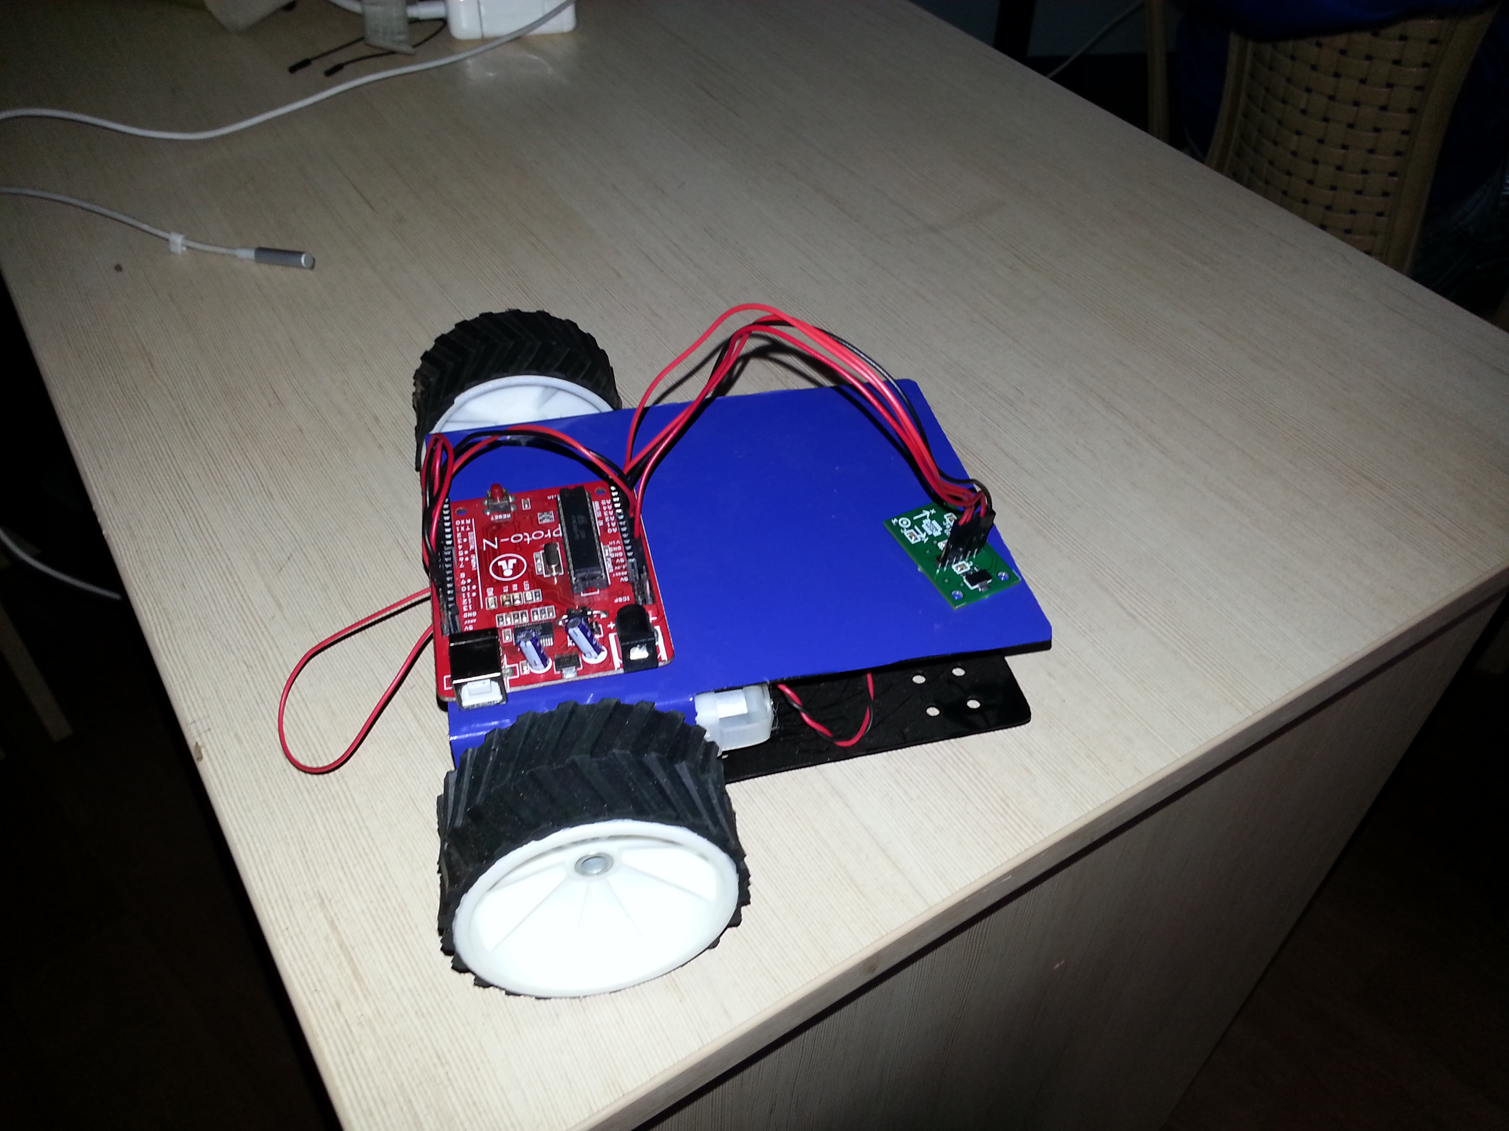

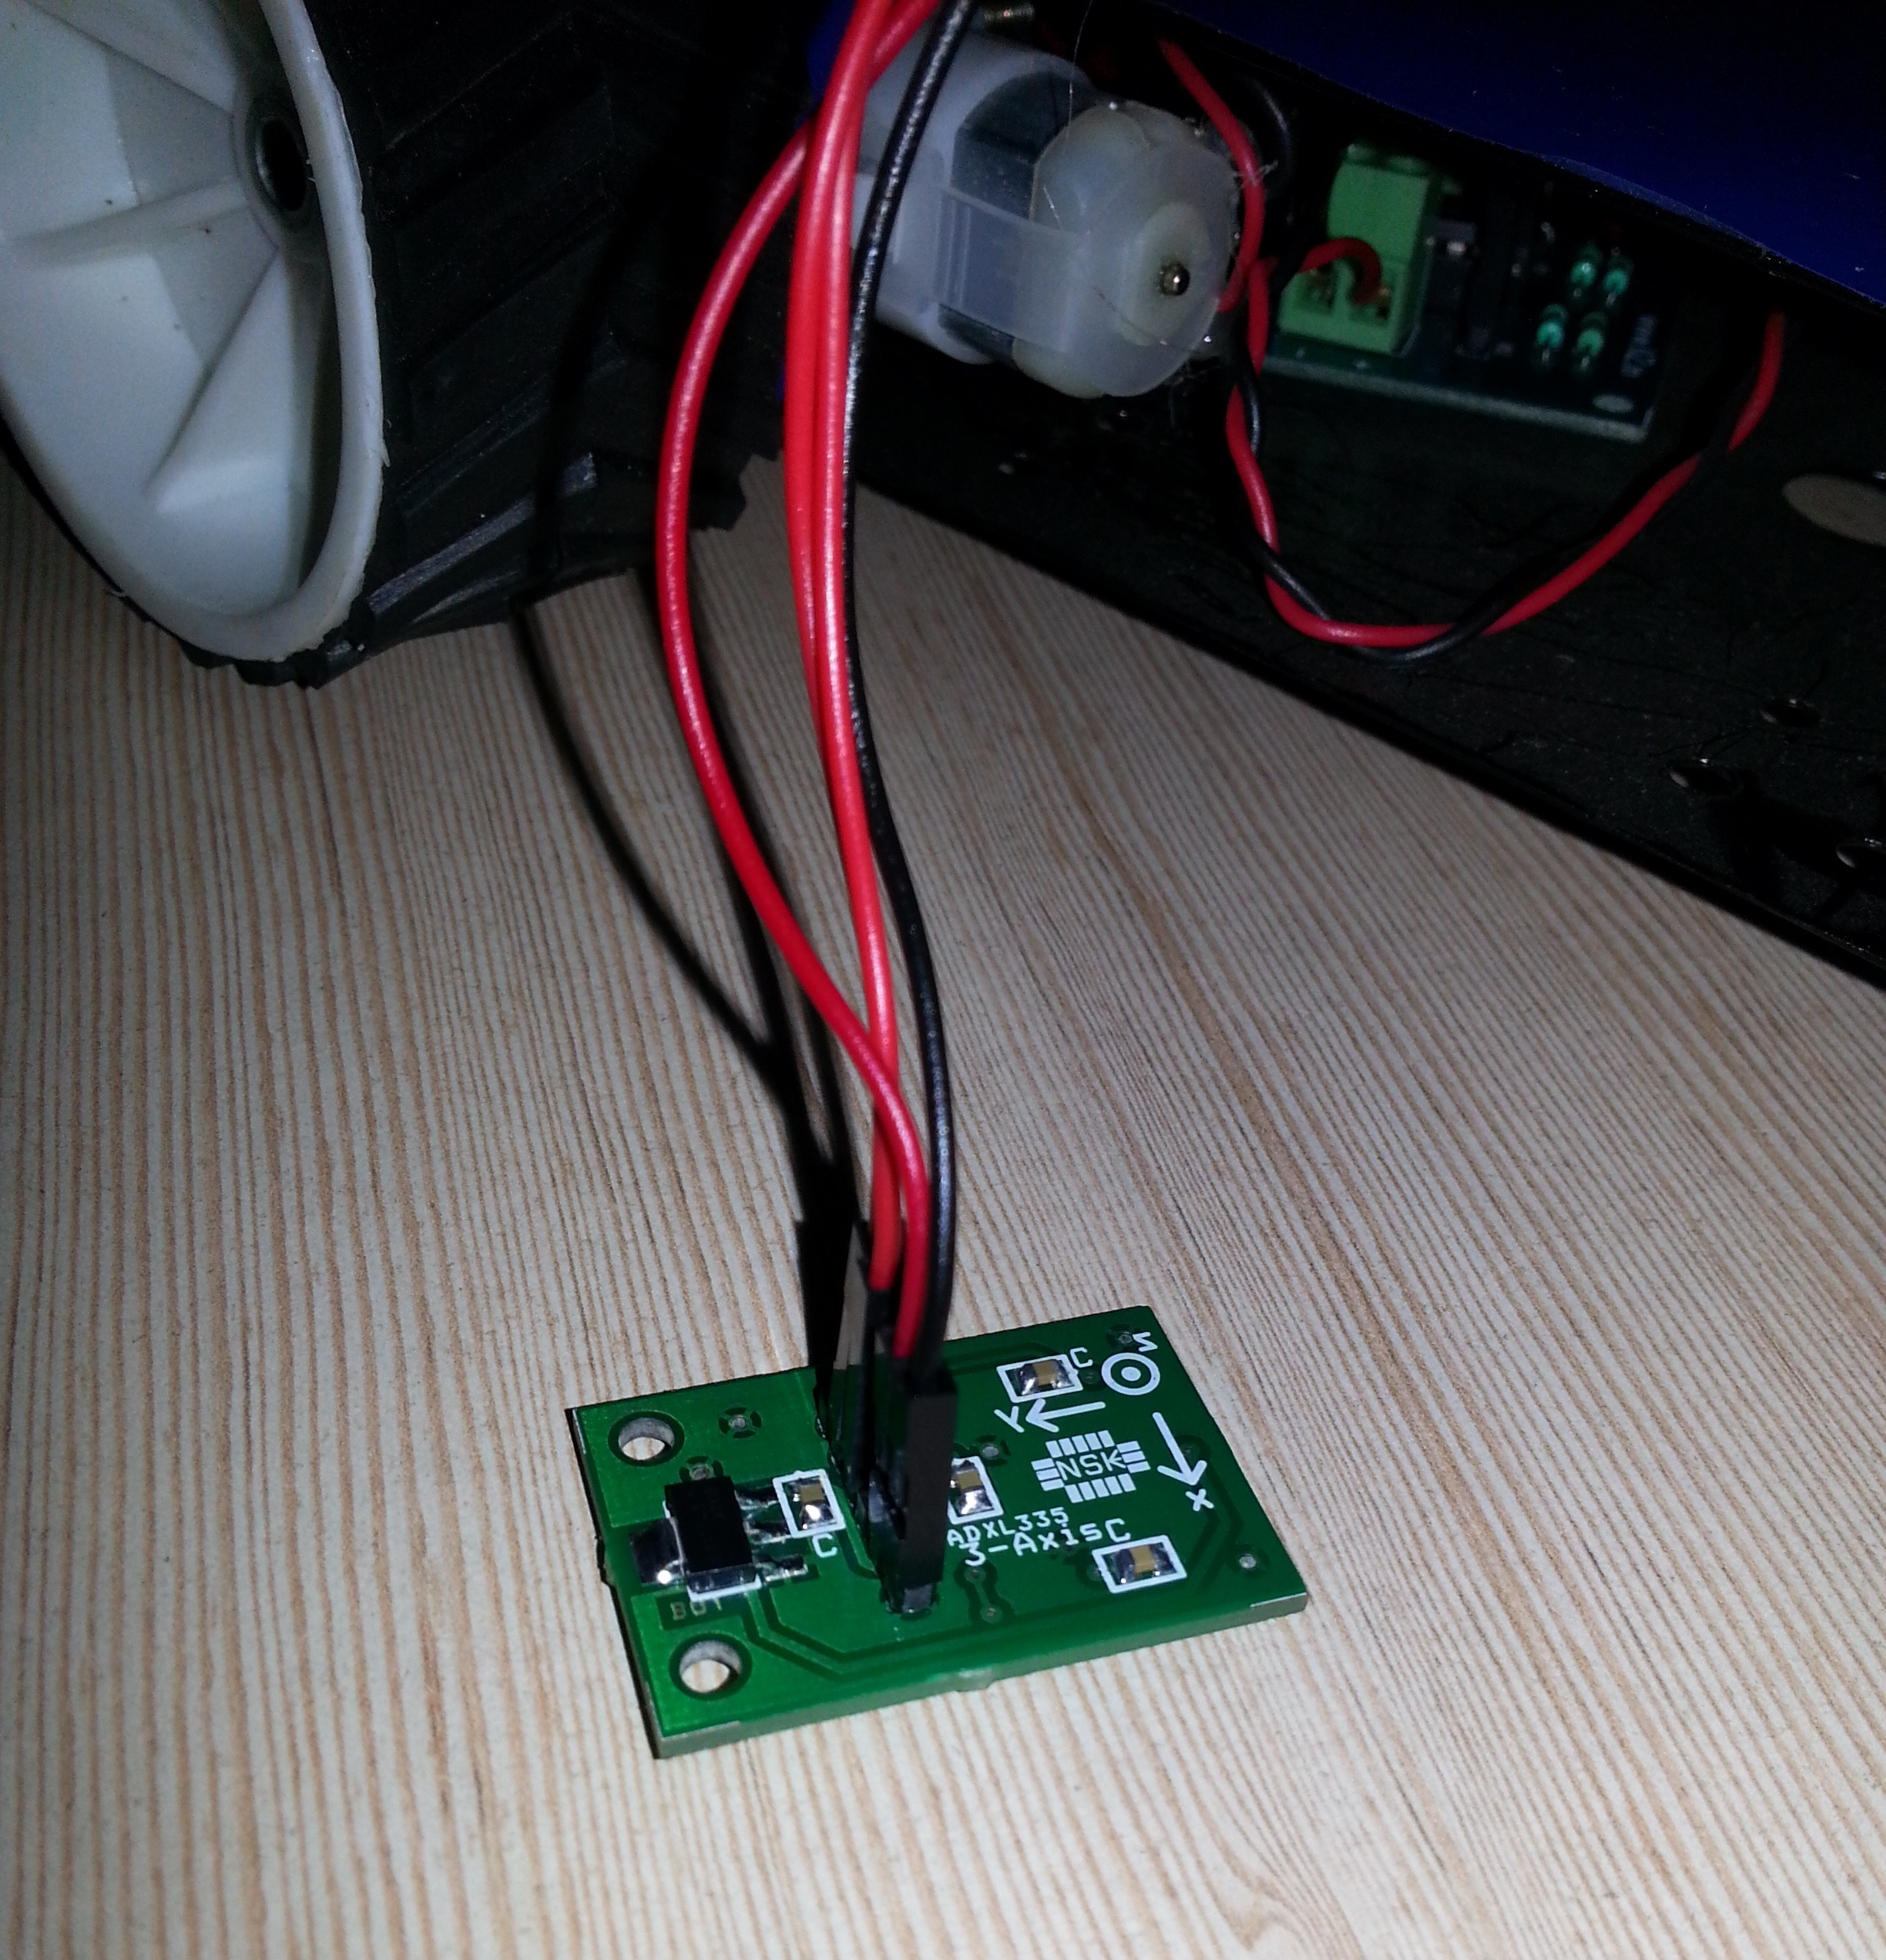

int Motor1Pin1=6;

int Motor1Pin2=7;

int Motor2Pin1=11;

int Motor2Pin2=12;

int x;

int y;

void setup()

{

pinMode(A0, INPUT);

pinMode(A1, INPUT);

pinMode(6, OUTPUT);

pinMode(7, OUTPUT);

pinMode(11, OUTPUT);

pinMode(12, OUTPUT);

Serial.begin(9600);

}

void loop()

{

x=analogRead(A0);

y=analogRead(A1);

x=map(x,250,400,0,10);

y=map(y,250,400,0,10);

Serial.print(x);

Serial.print(" ");

Serial.println(y);

delay(500);

if((x>=0 && x<4))

{

digitalWrite(Motor1Pin1, LOW);

digitalWrite(Motor1Pin2, HIGH);

digitalWrite(Motor2Pin1, LOW);

digitalWrite(Motor2Pin2, HIGH);

}

if((x>=6 && x<=10))

{

digitalWrite(Motor1Pin1, HIGH);

digitalWrite(Motor1Pin2, LOW);

digitalWrite(Motor2Pin1, HIGH);

digitalWrite(Motor2Pin2, LOW);

}

if((y>=0 && y<3))

{

digitalWrite(Motor1Pin1, LOW);

digitalWrite(Motor1Pin2, LOW);

digitalWrite(Motor2Pin1, LOW);

digitalWrite(Motor2Pin2, HIGH);

}

if((y>=7 && y<=10))

{

digitalWrite(Motor1Pin1, LOW);

digitalWrite(Motor1Pin2, HIGH);

digitalWrite(Motor2Pin1, LOW);

digitalWrite(Motor2Pin2, LOW);

}

if((x==5 && y==5))

{

digitalWrite(Motor1Pin1, LOW);

digitalWrite(Motor1Pin2, LOW);

digitalWrite(Motor2Pin1, LOW);

digitalWrite(Motor2Pin2, LOW);

}

}